**Testimonials**

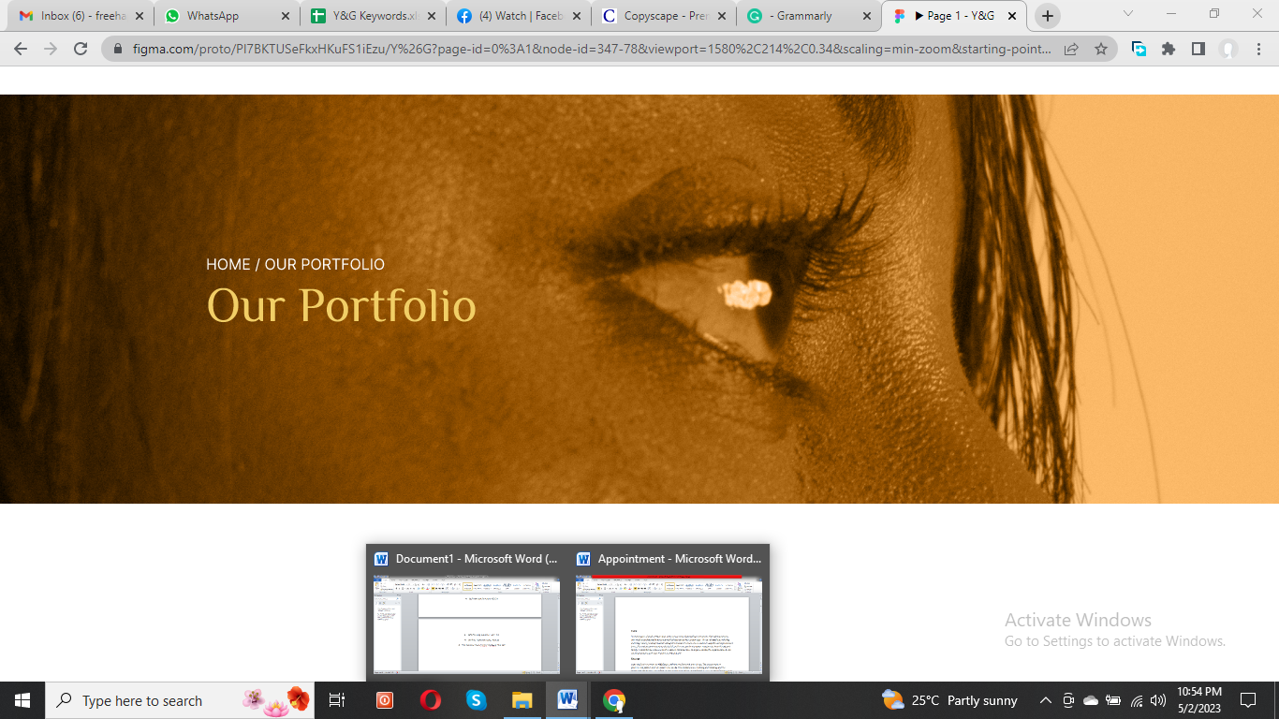

**Facial**

"I recently got a facial at Y&G Salon, and it was a truly rejuvenating experience. The esthetician was extremely knowledgeable and gave me the best advice for my skin type. The facial itself was relaxing and invigorating, leaving my skin feeling refreshed and radiant. I have noticed a significant improvement in my skin texture and tone since the facial, and I have received several compliments from friends and family. I would highly recommend Y&G Salon's facial services to anyone looking for a personalized and transformative experience. Thank you, Y&G Salon!"

**Massage**

I recently had a massage at Y&G Salon, which was a fantastic experience. The masseuse was professional, skilled, and attentive to my needs. The ambiance was calming and relaxing, and the massage techniques were perfect. I felt rejuvenated and renewed after the session. The salon's focus on hygiene and cleanliness was evident throughout my visit, which added to my overall satisfaction. I highly recommend Y&G Salon's massage services to anyone seeking a therapeutic and relaxing experience. I will be returning for more massages in the future. Thank you, Y&G Salon, for the incredible service!

**Hair Care Services**

I recently had a haircare service at Y & G Salon, one of the best experiences I have ever had at a salon. From the moment I walked in, I was impressed with the professionalism and skill of the hair experts. They took the time to assess my hair type and listened carefully to my concerns and preferences before recommending the best treatment and styling options. The result was a beautiful, healthy, stylish haircut that perfectly suited my personality and lifestyle. I highly recommend Y&G Salon to anyone looking for exceptional hair care services in Dubai.

**Eyelashes**

"I recently got my eyelashes done at Y&G Salon, and I couldn't be happier with the results. The staff was extremely friendly and welcoming, making me feel comfortable and relaxed throughout the entire process. My technician was highly skilled and took the time to understand exactly what I wanted, and they delivered just that. The results were stunning and exceeded my expectations - my eyelashes looked fuller, longer, and more defined. The best part? The results lasted for weeks! I highly recommend Y&G Salon for anyone looking for top-quality eyelash services."

**Nails**

"I had the best experience with Y&G Salon's nail services. The staff was extremely skilled and friendly. They took the time to understand my preferences and suggested what would look best for me. The atmosphere was relaxing and inviting, and the equipment and tools were top-notch. My nails turned out amazing and stayed beautiful for weeks. The salon also offered a wide range of colors and designs. Overall, I highly recommend Y&G Salon for anyone who wants to pamper themselves and get the best nail care service in Dubai."

**Threading Services**

I recently visited Y & G Salon for threading services and was impressed. The staff was very professional and ensured I was comfortable throughout the process. The threading was done with precision, and my eyebrows never looked better. The salon was also very clean and hygienic, which is important to me. Overall, I had a great experience and recommended Y & G Salon to anyone looking for high-quality threading services in Dubai. I will be returning for my next threading appointment!

**Waxing**

I had an amazing experience at Y&G Salon for my waxing service. The staff was extremely professional and knowledgeable, making me feel comfortable throughout the process. They used high-quality products and techniques that made my skin smooth and soft. I was impressed by the attention to detail and cared they put into the service. It was also reassuring to know that they follow strict hygiene and safety protocols to ensure a clean and safe environment. I highly recommend Y&G Salon for its exceptional waxing services and will be coming back for more.